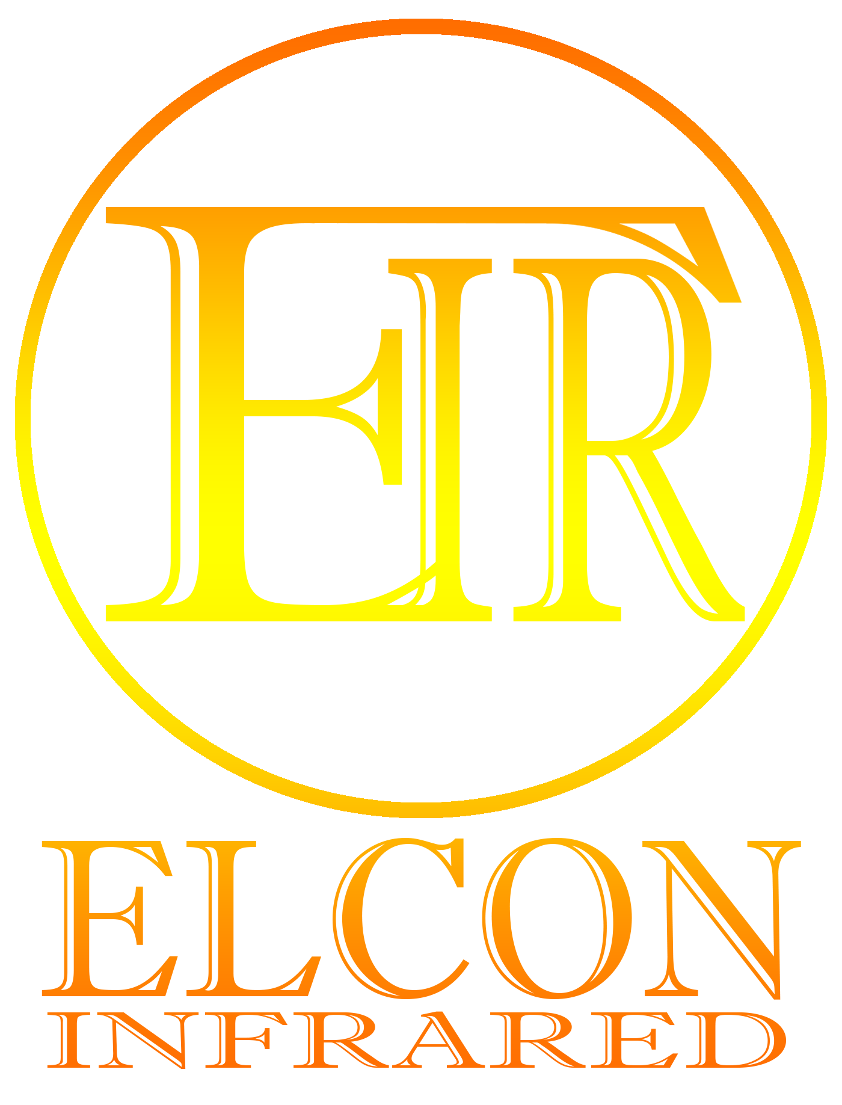
ELCON® INFRARED HEATING SYSTEMS
ELCON RCH-2500

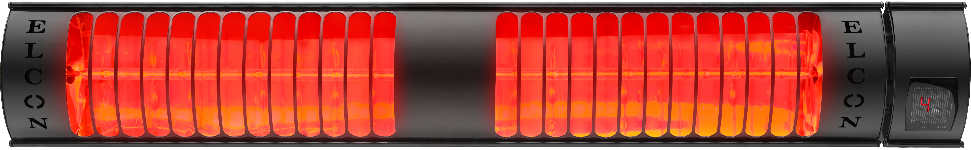
The shape of the warming is the way it moves with light and is the name given to some of the sunlight. The difference between infrared lights from other lights (blue, yellow, green, etc.) is that it can carry heat more than others. Infrared lights are also infrared lights that warm the world through space. Infrared lights are light in the wavelength range of 0.76-300 micrometers of the sun's rays. They are orange and light that can be clearly seen during the sunrise and sunset of the sun.
The biggest feature of infrared is the heating of objects directly without heating the air, i.e. using the air as an intermediary. It carries its temperature in the sun with its light up to Earth, and the ambient temperature increases even in the snowy weather in winter.
Due to these advantages, infrared heaters that come to mind first when it comes to regional heating system are a technology that relaxes with both elegance and comfort, leaving behind other heating systems with both pocket friendly and environmentally friendly in terms of investment and consumption cost.
Infrared heaters can be easily used both as bottom heating at the tables and as top heating with the help of wall or hanger apparatus. Infrared heaters, which add a distinct air to the places used with their stylish appearance, are used in many areas with their extremely simple installations.

WARNING
Industrial Type Infrared Heaters are not suitable for use in small and closed spaces such as homes, businesses, etc. Our company is not responsible for any bodily or material damages that may occur if used!
Read the usage manual carefully before the device is used! The user is responsible for the damage, loss and accidents incurred by individuals due to the failure to comply with the warnings in the manual of use. In this case, the device is excluded from the warranty scope for any failures.
PRODUCT SPECIFICATIONS
- IP67 water protection
- Compatibility with wall, hanger and foot apparatus
- Ease of assembly/disassembly
- No maintenance/repair required
- Long life with high quality parts
- Black and Gray color option
- 16m2 Heating area
- 3x2.0mm2 Power cable

- High density infrared technology
- 1.2 μm short wavelength
- 100% energy in 1 second
- 2500 W power consumption
- 235 VAC operating voltage
- 2100 °C filament temperature
- 670 x130x77 sizes
- 2 mm aluminum body structure
- Maximum heat transfer with the help of reflector

HOW IT WORKS
- For the device to work, it is sufficient to plug the plug cable into the outlet.
- There is no need to remove any part of the device for electrical connection.
- Do not install the appliance just below or above the electrically connected outlet.
- When a clear connection is requested, the electrical connection will need to be made with an on/off switch. This connection must be made by an expert person.
- For electrical connection, grounding must exist in the installation, the existing grounding must be sufficient.
- Before the device is assembled, the mounting height in the specifications section should be taken into account and hung or fixed appropriately.
- It should be checked whether the installation where the electrical connection is made is capable of removing the power of the device.
- Our company is not responsible for any damages that may occur if the device is installed where there is no grounding or insufficient electrical installation.
- To get information, see www.infrared.com.tr.
- The device has one heater connection apparatus in the device box for installation of the device, one wall connection apparatus, 2 rondels, 1 long screw and 3 screws for fixing to the wall.
- The action steps that need to be followed for the installation of the infrared heater to the wall are as follows:
- The hole locations are determined for the wall hanger apparatus.
- Fixed to the wall or profile with the help of 3 dowels and screws. The heater connection is mounted on the channel and squeezed with the help of the channel tightening screws on it and fixed to the heater. To flow two apparatus; The first long screw (Screw-1) is squeezed with butterfly screws to secure the wall and heater apparatus as seen in the way it is seen. The second long screw (Vida-2) is squeezed with a butterfly screw instead of switching the screw of the heater apparatus through the oval hole in the wall apparatus. The screw in the oval hole can be moved to 45 degrees adjustable.
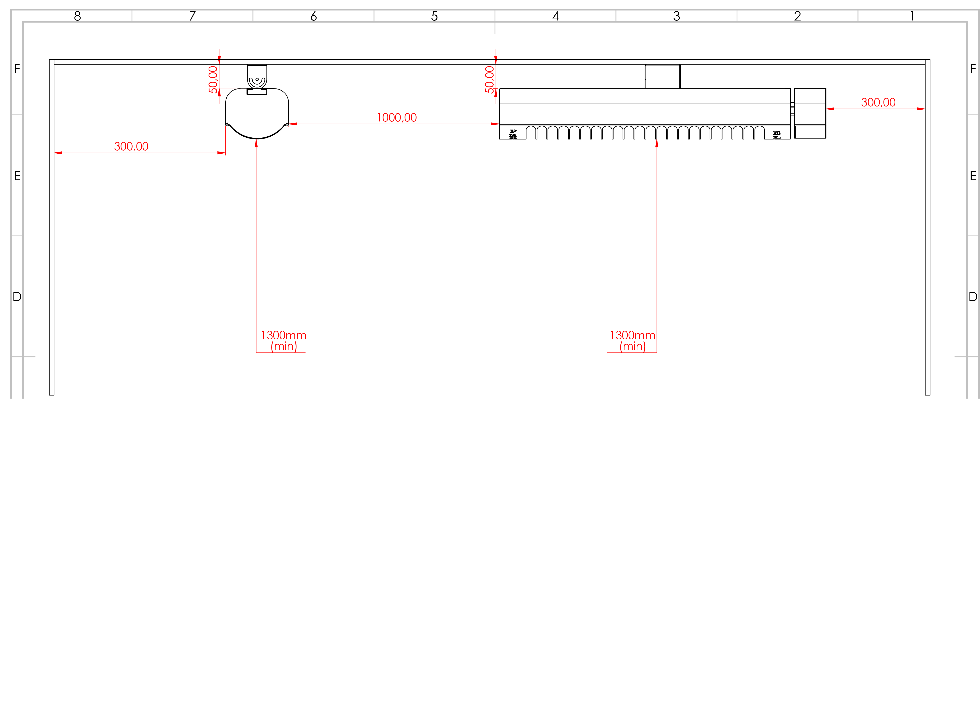
Wall
Wall
Ceiling
Ceiling

50.00

50.00
300.00
1000.00
300.00
Patio heater

Distance to closest object

1300mm min
1300mm min
Roof ground level

SAFETY CONSIDERATIONS

WARNING
The following instructions must be followed without the use of industrial type Infrared Heater.
- Use the appliance only for general, local or point heating purposes. Our company is not responsible for any damages arising from failures otherwise encountered.
- It is necessary to assemble at least 60 cm between the surface to be heated with The Golden Infrared inside the appliance.
- Mounting distance: Minimum mounting load 1500mm/ Maximum mounting load 3000mm
- Do not use the device in environments where pets are freely roaming, such as flying, jumping, etc.
- Do not use the flasher, explosives and immediately flammable materials in the areas where they are stored.
- Never touch the Golden infrared lamp in the appliance by hand. If you touch the infrared lamp manually, slowly wipe the location of your handprint with soft cloth. Otherwise, the dirt and dust left over the lamp will burn and damage the working life.
- Use the appliance with a plug-in cable. If any additional action is taken and used, the device will be covered by the warranty.
- The electrical connection of the device is made with 220/240VAC mains voltage.
- Connect the appliance with a grounded outlet that can carry 16A current.
- In order for the device to be used in a perpendicular position, the controller must remain at the bottom according to the position of the card module. Our company is not responsible for any technical failures that may occur otherwise and is not covered by the warranty.**
- The screen on the device opens as soon as it is energized. Only ' until any action is performed on the screen. ' symbol appears. **
** Applies only to RCH Series remote-controlled infrared heaters.

WARNING
- TO REDUCE THE RISK OF FIRE OR ELECTRIC SHOCK DO NOT USE WITH AN EXTENSION CORD.

Control Usage **
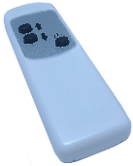
RCH Series infrared heater control consists of 4 keys. These keys are ten/off keys and up and down the adjustment keys for heater power. With the infrared heater control module, power can be adjusted to 50%, 70%, 85%, 100%, respectively. As soon as the screen on the Infrared heater is pressed to its ten position – the sign will appear. Then we can start the heater by increasing it with the upward key.
** Applies only to RCH Series remote-controlled infrared heaters.
Disassembly:
- The following steps are applied to disassemble the Infrared Heater in your business.
- If you use the appliance uninsured through insurance, the power connection is disconnected by the authorized person.
- The screws of the device's wall or hanger apparatus are removed.
- The dismantled device is left in its own box and balloon bag. Or a suitable box can be taken and removed by leaving a protective foam or balloon bag inside.
- Hanger apparatus and screws are left in a small bag and stored.

Maintenance – Repair – Cleaning
- Infrared heaters can be used for the duration of the life approved by the Ministry of Industry without any maintenance repairs( except for failures).
- Never touch the golden infrared lamp when cleaning the infrared heaters. You can carefully clean the reflector placed section in the interior of the aluminum body with the air with a hairdryer or vacuum cleaner.
- You can carefully wipe the outer surface of the aluminum body with the help of a dry cloth. However, if the aluminum body temperature is high, do not wear cloth. Otherwise, electrostatic powder paint on the device may be deformed due to high temperature.
- Do not clean without power disconnected!

LIMITED WARRANTY
To the consumer, ELCON AUTOMATION warrants this product to be free of defects in materials or workmanship commencing upon the date of the original purchase. In order to be eligible for this Limited Warranty, an original sales receipt or comparable substitute proof of purchase bearing the date of original purchase is required. Refer to the original product carton or specific product/model page on the ELCON AUTOMATION website for warranty length for your particular model. This warranty applies only to the original purchaser of this product from the original date of purchase. This warranty covers product purchased from authorized distributors only.
This warranty applies to repair or replacement of product found to be defective in materials or workmanship. This warranty does not apply to damage resulting from unusual wear, commercial, abusive, unreasonable use or supplemental damage. This warranty does not cover damage from unauthorized repairs or from any use not in accordance with the instruction manual. Defects that are the result of normal wear and tear will not be considered manufacturing defects under this warranty.
If this product should become defective within the warranty period, we will repair or replace any defective parts free of charge. All warranty repairs must be completed by ELCON AUTOMATION. This warranty gives you specific legal rights.
To submit product under warranty the complete machine must be delivered pre-paid to ELCON AUTOMATION. Please include complete information including: the problem, the model number of the product, the day of purchase, and a copy of the original sales receipt along with your name, address, and telephone (email optional). Address returns to the attention of:
Customer Service, at the address below. Additional questions or comments can be made toll free to the number listed below

ELCON AUTOMATION INDUSTRIAL & HEATING SYSTEMS
PERPA TRADE OFFICE B BLOCK NO:1857 SİSLİ/İSTANBUL
Country: Turkey
City: Istanbul
Postal: 34384

